**Program Five Part One:**

//summary: This program finds the largest integer that is less that 12,000 when cubed by using a while loop

//name: Jenna Wolf

//class: Fundamentals of Programming, CS155 - 01

//instructor: Dr. Art Kazmierczak

//date: 9/18/2023

public class Main

{

public static void main(String[] args) {

int i = 1; //holds the data for i and sets it to 1

//tells the user what the program is doing

System.out.println("This program finds the largest integer that is less than 12,000 when cubed");

//while loop that iterates while i + 1 cubed is less that 12000

while(Math.pow(i + 1, 3) < 12000)

i++; //adds 1 to i

//tells the user which integer cubed is less than 12,000

System.out.println("The largest integer that is less than 12,000 when cubed is " + i);

}

}

**Output:**

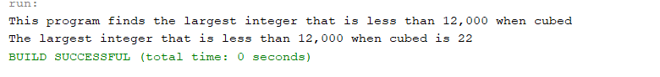

**Program Five Part Two:**

//summary: This program displays the ASCII charcters in a tabular form from ! to ~

//name: Jenna Wolf

//class: Fundamentals of Programming, CS155 - 01

//instructor: Dr. Art Kazmierczak

//date: 9/18/2023

public class Main

{

public static void main(String[] args) {

int j = 0; //holds the j data and sets it to 0

//tells the user what the program is doing

System.out.println("This program displays the ASCII table from ! to ~");

//for loop that creates i and sets it to 33, makes sure i us less than 127, and adds 1 to i each time

for(int i = 33; i < 127; i++)

{

System.out.print((char)i + " "); //prints out the ASCII character and a space

j++; //adds 1 to j

//checks if j equals 10

if(j == 10)

{

j = 0; //sets j to 0

System.out.println(); //ends the current line

}

}

}

}

**Output:**

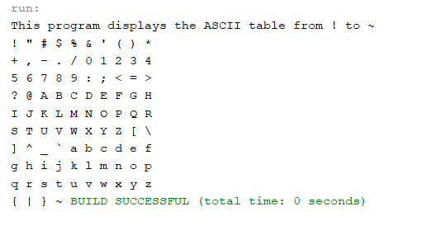

**Program Five Part Three:**

//summary: This program takes in the loan amount and loan period anf finds the monthly payment and total payment

// for that loan from 5% to 8% using increments of 1/8

//name: Jenna Wolf

//class: Fundamentals of Programming, CS155 - 01

//instructor: Dr. Art Kazmierczak

//date: 9/18/2023

import java.util.Scanner; //allows inputs to be made

public class Main

{

public static void main(String[] args) {

Scanner input = new Scanner(System.in); //labels input as input

int loanPeriod; //holds the loanPeriod data

double loanAmount, monthlyPay, totalPay, monthlyInterest; //hold the data for each variable

//asks for and takes in the loan amount

System.out.print("Please enter your loan amount: ");

loanAmount = input.nextDouble();

//asks for and takes in the loan period

System.out.print("Please enter your loan period (in years): ");

loanPeriod = input.nextInt();

//creates a space and displays each column header

System.out.println();

System.out.println("Interest Rate Monthly Payment Total Payment");

//for loap that creates i and sets it to 5%, keeps going while i is less that 8.125%, and adds 0.125% each time

for(double i = 0.05; i < 0.08125; i = i + 0.00125)

{

// caculates the monthly interest rate, the monthly pay, and the total pay

monthlyInterest = i / 12;

monthlyPay = (loanAmount * monthlyInterest) / (1 - 1 / Math.pow(1 + monthlyInterest, loanPeriod * 12));;

totalPay = monthlyPay * 12 * loanPeriod;

//displays the percentage of interest, the monthly pay, and the total pay

System.out.printf("%-5.3f%%", i * 100);

System.out.print(" $");

System.out.printf("%-18.2f", monthlyPay);

System.out.print("$");

System.out.printf("%-10.2f", totalPay);

System.out.println();

}

}

}

**Output:**

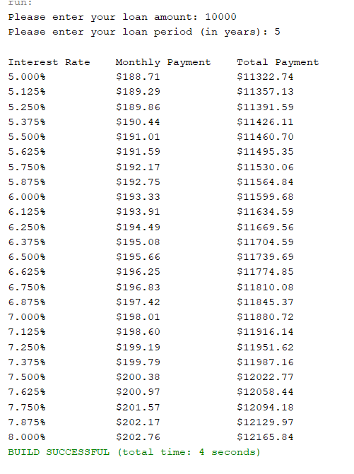

**Program Five Part Four:**

//summary: This program finds all the leap years between 101 and 2100 and displays them, 10 per line. It then displays

// how many leap years are between these two years (note: leap years take place every 4 years no counting end of

// century dates that are not divisable by 400 [2000 was a leap year, 1900 was not])

//name: Jenna Wolf

//class: Fundamentals of Programming, CS155 - 01

//instructor: Dr. Art Kazmierczak

//date: 9/18/2023

public class Main

{

public static void main(String[] args)

{

int count = 0; //holds the count data and sets it to 0

//tells the user what the program does

System.out.println("This program displays all the leap years from the year 101 to the year 2100");

//for loop that creates i and sets it to 101, makes sure i is less than 2101, and adds 1 to i each loop

for(int i = 101; i < 2101; i++)

{

//if statement that checks if i is divisable by 400 or if i is divisable by 4 but not 100

if(i % 400 == 0 || (i % 4 == 0 && i % 100 != 0))

{

//outputs the current leap year and a space

System.out.print(i + " ");

count++; //count has 1 added to it

//checks to see if count is divisable by 10. if it is, ends the current line.

if(count % 10 == 0)

System.out.println();

}

}

//displays how many leap years there are between 101 and 2100

System.out.println();

System.out.println("There are " + count + " leap years in the period of time between 101 and 2100");

}

}

**Output:**

